The Language of RNA: a formal grammar that includes pseudoknots
Elena Rivas and Sean R. Eddy
Bioinformatics, vol. 16, no. 4 2000, pp.334-340
Abstract
The context-sensitive rules isn’t good at describing pseudoknotted structure. In this paper, authors presented a context-free representation to describe RNA secondary structure including pseudoknots.
- Introduction
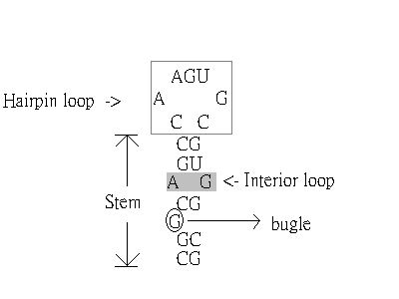
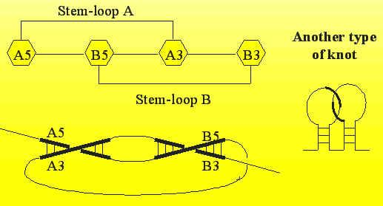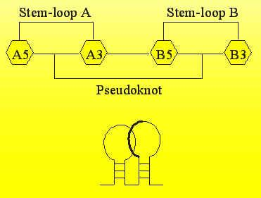
2.Crossed-interaction grammar
。G = { V , T , S , I , P , R }
V : nonterminal symbols
T : terminal symbols (ε→empty string, Λ →hole string)
S : start nonterminal symbols (S V)
I : extra nonterminal symbols
P : productions (I only appear in the right-hand side of productions)
R : rearrangement rules (extra symbols are used to rearrange)
。A language that includes crossing interactions is a “copy language” (it needs two nonterminals to generate copy language V ={V , V_{H} })
。In order to represent cross interactions, we need 3 extra symbols :
I = { ( , ) , × }
。Λ(hole string) : the possible point of insertion of another string
。In this case we use one rearrangement rule:
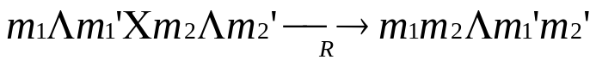
。Example of copy language:
L = {ε, ωΛω ︳ω(a, b)* }
I = {(, ) ,× }
W → WW ︳( W_{H} × W_{H} ) ︳ε
W_{H} → aΛa ︳bΛb ︳( W_{H} × W_{H} )︳Λ
R =
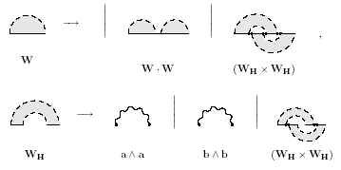
3.RNA pseudoknot grammar
V = { W , W_{B} , V^{ab} ,W_{H},V_{H}^{abcd} , IS1 , IS2 }
T_{RNA} = { a , u , c , g }
I = { ( , ) , × , ×_{L} , ×_{R} , }
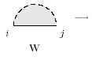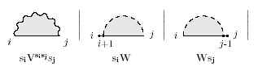
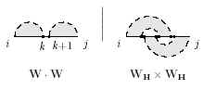
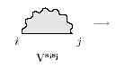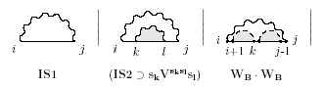
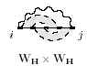
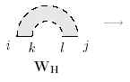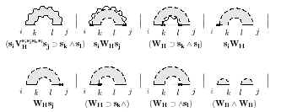
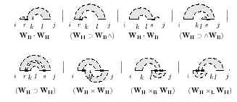
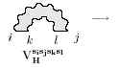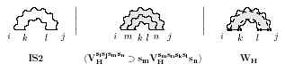

For hairpin loops:
IS1 → ε︳s₁︳s₁s₂︳…︳s₁…s_{maxloop}

Loops closed by two interactions (stems, bugles and internal loops)
IS2 → 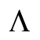︳s₁…s_{k}︳s₁…s_{k}︳s₁…s_{i-1}s_{i}…s_{k}
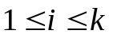 and 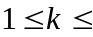maxloop

Rearrangement rules:
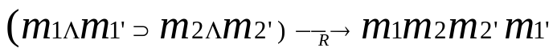
for any sequence m₁, m₁’, m₂ and m₂’ T*
4.Conclusion

Created by: Chia-Ling Sun
Date: March, 19, 2003

